Steps to add levels – Reactor Rod

Code section for setting variables/graphics/sounds for the level

Each level has a section in the code called ‘mapLevel1’, ‘mapLevel2’ etc.
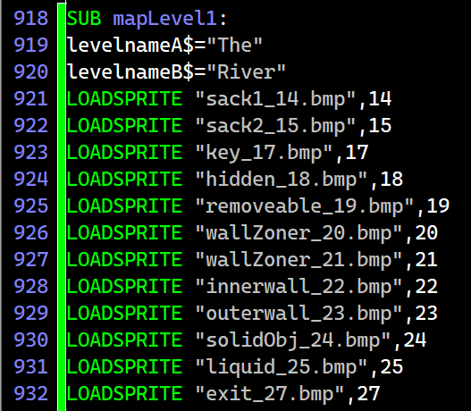
This contains LOADSPRITES etc for each level, LOADSOUNDS and the read statements for the movements of the enemy (pattern).

Define movements for pattern enemies

The pattern variables are held in the subs ‘enemyMoves1’ etc.
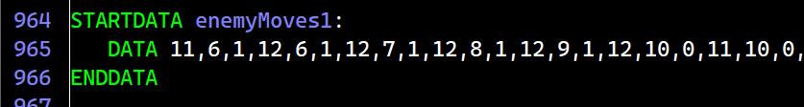
The enemy moves numbers are x, y and direction facing (left=0, 1=right).
EnemyOne is the pattern follower. These should only be 1 per level.
EnemyTwo are followers and multiple ones can be added on each level.

LevNumGen

The level number generator creates a small file (“levelNumbers.dat”). Run the exe file LevelNumGen.exe, set the number of levels in the game then save.
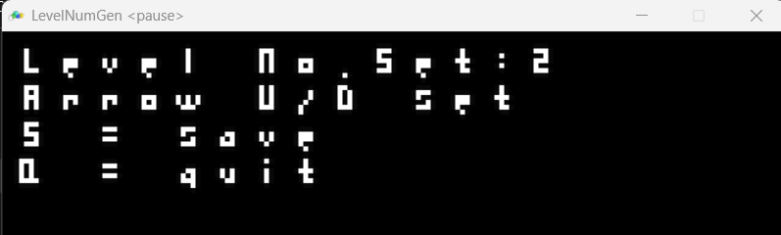
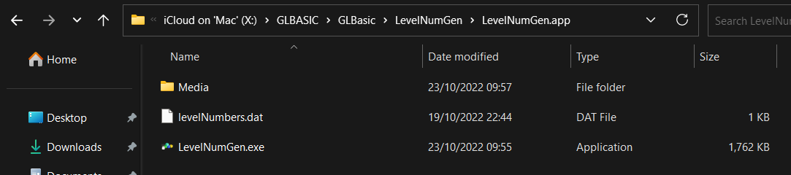
Then copy the levelNumbers.dat to the Media folder of Reactor Rod.
When the game runs it reads the file to determine the number of levels. This is used in the code to know when all the levels are completed.
By having this variable as a separate file it’s easier to amend the number of levels without having to hunt through the variables in the code.

Use level builder to generate level file

Make additional levels using the level builder. Loading in a file brings in file ‘leveldata.dat’ in the LevelBuilder Media sub-folder. Saving will write to the same filename. Reactor Rod will read in filenames with the level number appended, eg ‘leveldata1.dat’. Copy the files to the Media folder of Reactor Rod.

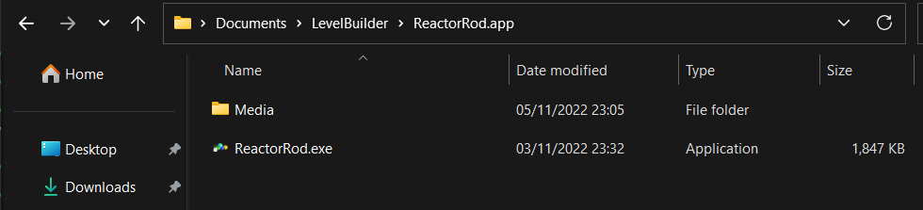
Run the ReactorRod.exe file in the levelBuilder folder.
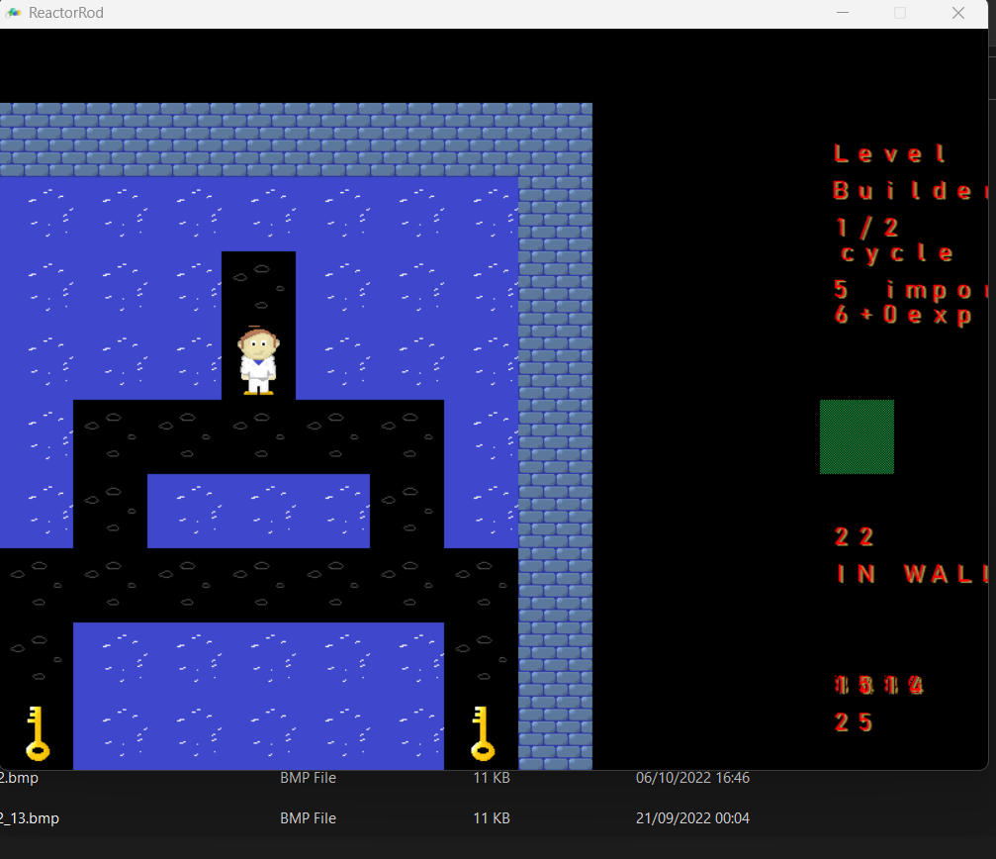

Level builder:
5 import
6 + 0 Export (automatically overwrites leveldata.dat)
Use cursor keys to move around.
Use 1 and 2 to move up and down the sprite numbers. Some numbers are blank and can be ignored. There’s a number for a blank, but for most areas walked on use the rocks.
EnemyOne (pattern) can be plotted, but it isn’t implemented on the game. To do this use the Define movements for pattern enemies above.

Change the loop settings (2 or 3 places in the code - tbc) so number of levels is set

This part of the code could be refined.
In the main loop, look for the following sections of code:-
This part needs updating to add additional cases statements for the the level reset, so the correct sprites/sounds/variable subs are called.

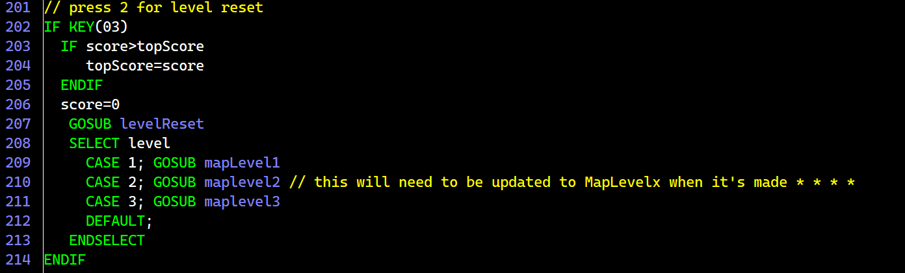
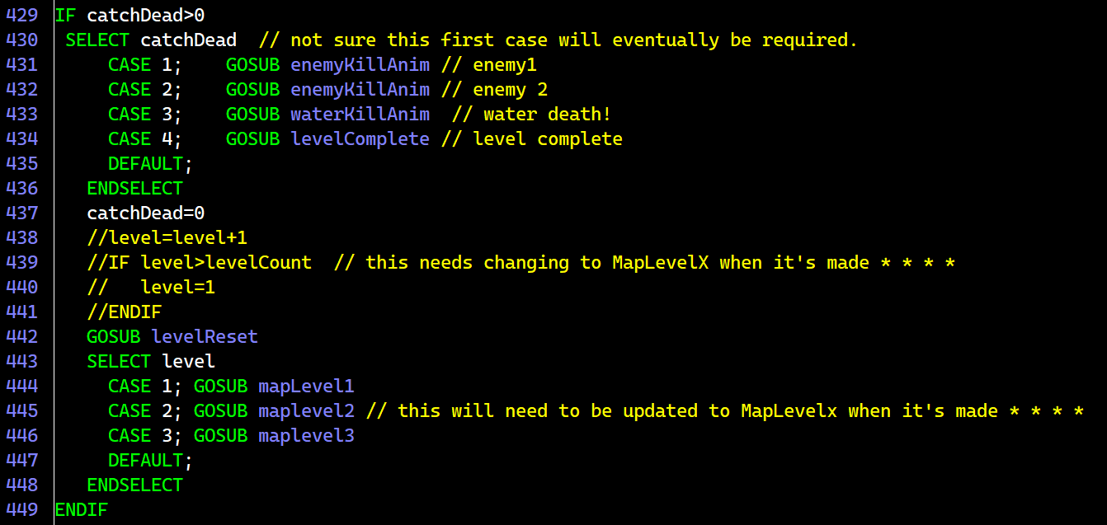
Update the case statements to account for each level.

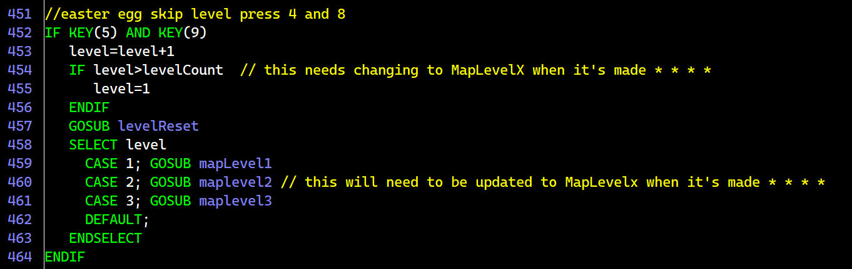
Update this section for the easter egg keypress.

